  April 22nd, 2021  7:00pm – 8:30pm  Limited Space, Please RSVP To:  NV Black @co.pg.md.us  NMRogers@co.pg.md.us  BASmith@co.pg.md.us  Or  JJWood@co.pg.md.us  Zoom link will be provided prior to event  Prince George’s County Police District II COPS Presents Virtual Night-In, A Community Roundtable. This event is designed to inform Prince Georgians what services have been modified and new services created for residents to navigate through the current COVID-19 Pandemic which has reshaped our lives.  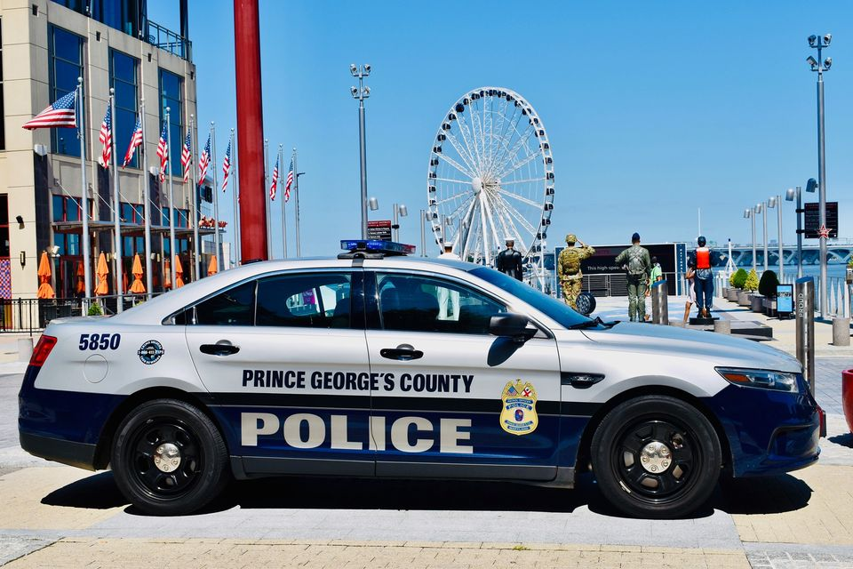 | A Virtual Community Roundtable  ────  Special Guests Include:  ────  Health Department’s Doctor Carter  ────  Prince George’s County Council Members  ────  PGPD District II Command Staff  Also Featuring  District II COPS  District II Explorer Advisor  Department of Public Works and Transportation (DPWT)  Department of Permitting Inspections and Enforcement (DPIE)  Employ Prince George’s  And moRe to be named

