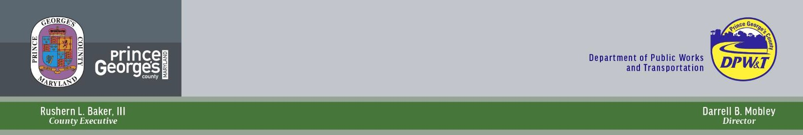

**CHURCH ROAD**

**TEMPORARY ROAD CLOSURE**

**PUBLIC INFORMATION MEETING**

**MAY 19, 2021**

Angela D. Alsobrooks

*County Executive*

Terry L. Bellamy

*Director*

**VIRTUAL COMMUNITY MEETING ANNOUNCEMENT**

The Prince George’s County Department of Public Works and Transportation (DPW&T) has identified your neighborhood as one that will be impacted by the upcoming temporary road closure of Church Road, between Dormansville Boulevard and Mary Bowie Parkway (0.4 miles). DPW&T held a virtual Public Hearing on March 30, 2020 to discuss the closure with the community.

DPW&T will join a follow-up virtual community meeting on May 19, 2021 at 7:00 PM. This meeting will provide community members the opportunity to understand the scope of work and timeline. This will also serve as an opportunity to ask questions and provide feedback.

Maps and visual information about the project will be presented during the virtual meeting. In addition, representatives from DPW&T and Woodlawn Development Group will be available to take your questions.

**You can join this meeting from your computer, tablet or smartphone by using the below link:**   
 <https://zoom.us/j/92127292629?pwd=SGJBN0p2aWQxeFdhUTNTWEhEc2haZz09>

|  |
| --- |
| **Project Location** |
|
|

**ANTICIPATED PROJECT SCHEDULE:**

|  |  |
| --- | --- |
| Temporary Church Road closure is anticipated on or about June 17, 2021 for approximately 7 months. | |
| **WHEN:** | **FOR MORE INFORMATION:** |
| **May 19, 2021** | If you have any questions, please contact:  Elizabeth Miller  Chief of Engineering Services Section  Department of Public Works and Transportation  9400 Peppercorn Place, Suite 400  Largo, Maryland 20774  Phone: (240) 883-5642  Email: [EFMiller@co.pg.md.us](mailto:EFMiller@co.pg.md.us) |
| **WHERE:** |
| Virtual Zoom Meeting: <https://zoom.us/j/92127292629?pwd=SGJBN0p2aWQxeFdhUTNTWEhEc2haZz09>  **Meeting ID: 921 2729 2629 Dial by your location:**  +1 301 715 8592 US (Washington DC)  +1 646 558 8656 US (New York)  +1 312 626 6799 US (Chicago)  +1 253 215 8782 US (Tacoma)  +1 346 248 7799 US (Houston)  +1 669 900 9128 US (San Jose) |
| ***We hope you can attend this virtual public information meeting!*** | |



Department of Public Works and Transportation

9400 Peppercorn Place, Suite 400

Largo, MD 20774