**OAK CREEK CLUB HOMEOWNERS ASSOCIATION**

**SPEED RADAR STATS FOR August 1, 2024 to August 31, 2024**

**RADAR LOCATION: ARGOS PLACE**

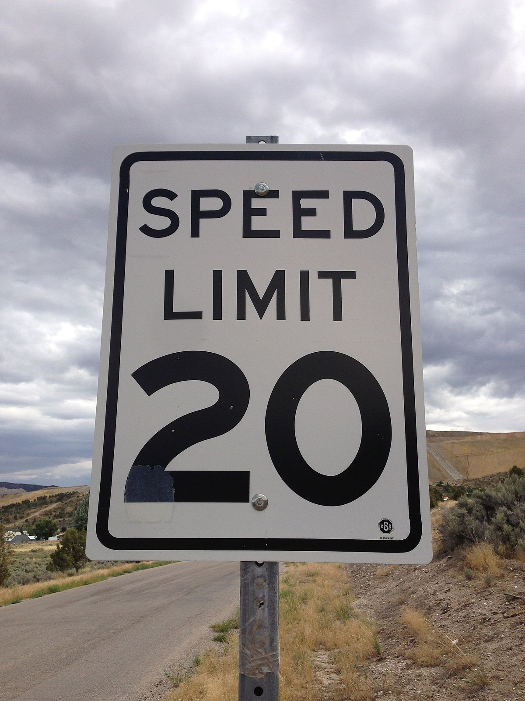

[This Photo](https://commons.wikimedia.org/wiki/File:2014-08-11_15_01_06_A_20_miles_per_hour_speed_limit_sign_on_Sage_Street_in_Ruth,_Nevada.JPG) by Unknown Author is licensed under [CC BY-SA](https://creativecommons.org/licenses/by-sa/3.0/)

TOTAL VEHICLE COUNT: 14,250

**Total Speed Violations: 5,701**

**Max Speed Reached: 46- 50 mph.**

**TIPS TO ASSIST WITH REDUCING SPEED WITHIN OAK CREEK**

* **Communicate the 20 MPH Speed Limit to all household members, vendors, and guests.**
* **Report any delivery drivers speeding in the community to the delivery company, access control, and the management team.**
* **Leave a little earlier, give yourself time.**
* **Be aware of pedestrians, bicyclists, and pets.**
* **Lead by example**
* **Use Cruise Control**

**REDUCING SPEED IS A COMMUNITY EFFORT**

**PLEASE DRIVE SAFE**